**Image processing & Machine Vision**

**Assignment – 01**

**Name: MPSM Pathirana**

**Reg No: D/ENG/22/0061/EE**

**Git Hub Link:** [**https://github.com/Sandeepa0/Image-Processing**](https://github.com/Sandeepa0/Image-Processing)

**Question 01**

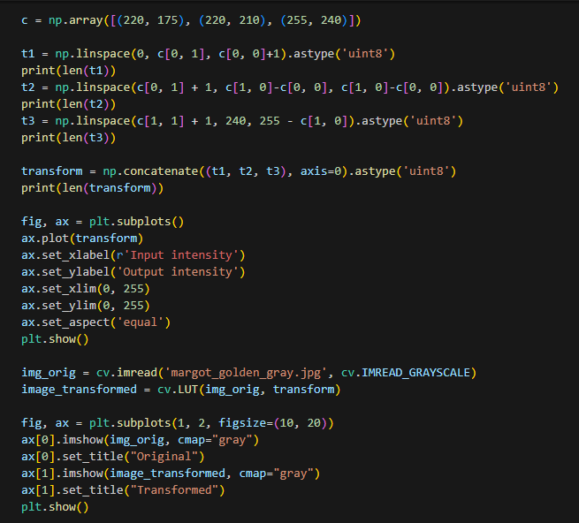

Intensity transformation plays a crucial role in adjusting the overall brightness, contrast, and other adjustment of the images. Also, intensity transformation is the fundamental process in image processing that can modify the pixel values. I attached the code and results.

**Question 02**

1. A computer screen shot of text

   Description automatically generated

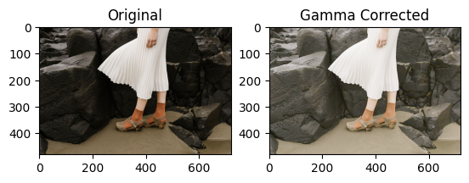

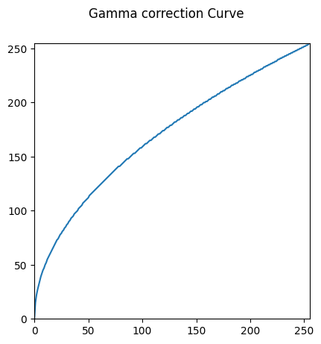

1. 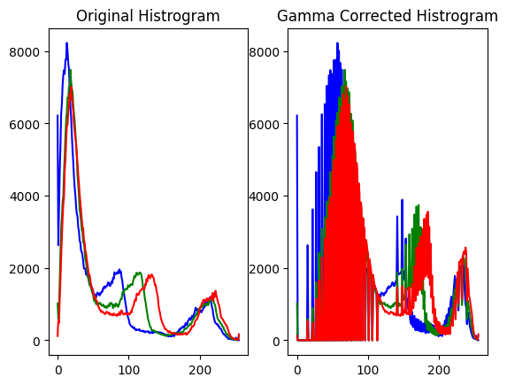A computer screen shot of text

   Description automatically generated

Histograms show a visual representation of the distribution of pixel intensities in an image. Original Histogram color spaces reflect the pixel intensities in the L channel. Indicate how common each intensities level is within the image. After applying gamma correction alters the relationship between the input and output pixel intensities this one affected overall brightness and contrast.

**Question 03**

1. **A computer screen shot of text

   Description automatically generated**

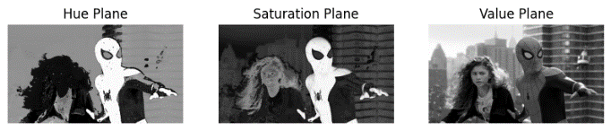

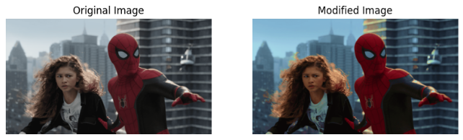

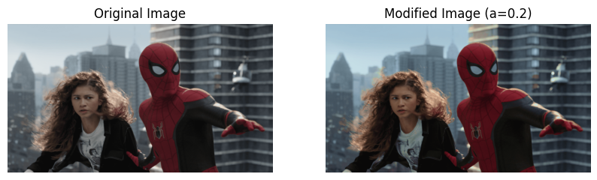

1. A collage of two people

   Description automatically generated
2. A screen shot of a computer program

   Description automatically generated

Under this question we consider the image enhancement process after we increase the vibrance of an image by applying intensity transformation to the saturation, HUE, HSV planes. Considering these three planes we focus directed towards enhancing and bringing out more vivid colors. The intensity transformation involves a parameter ‘a’ is adjusted to achieve a pleasing vibrance enhancement.

**Question 04**

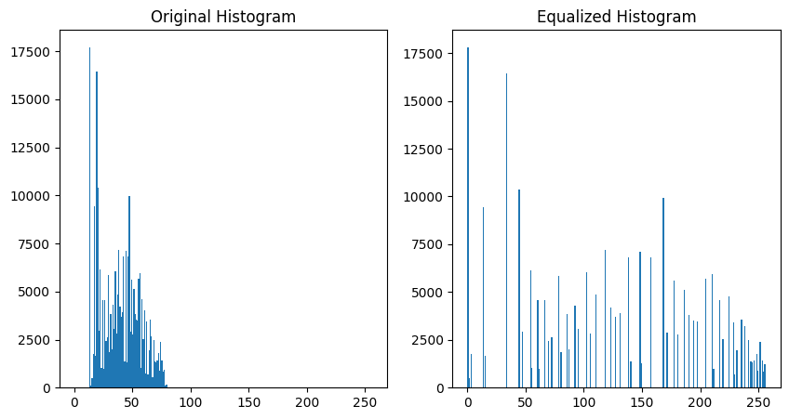

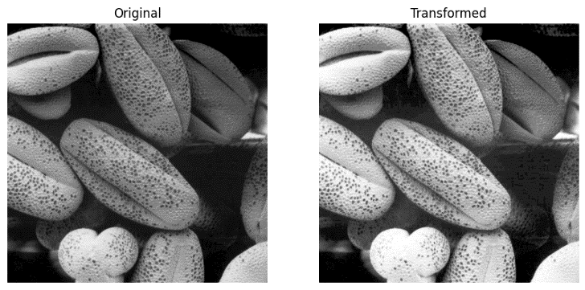

**Question 05**

1. 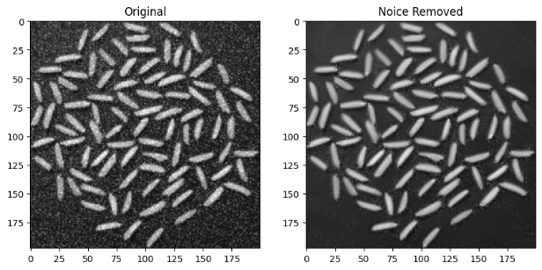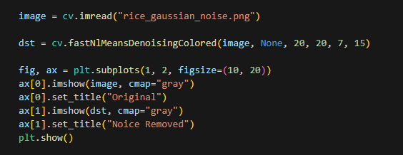

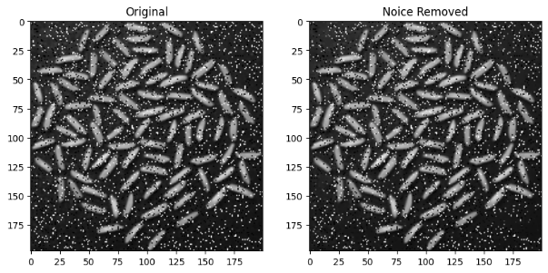

1. A computer screen with text and images

   Description automatically generated

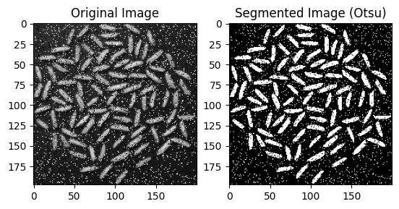

1. 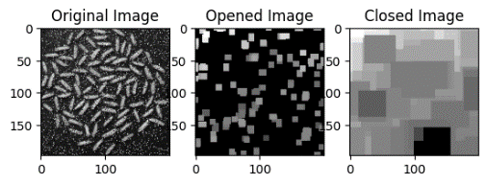



Otsu’s method applied to segment the images, disfurnishing rice grains from the background. Morphological operations refine the segmentation by eliminating small artifacts and filling in gaps.

**Question 06**

1. 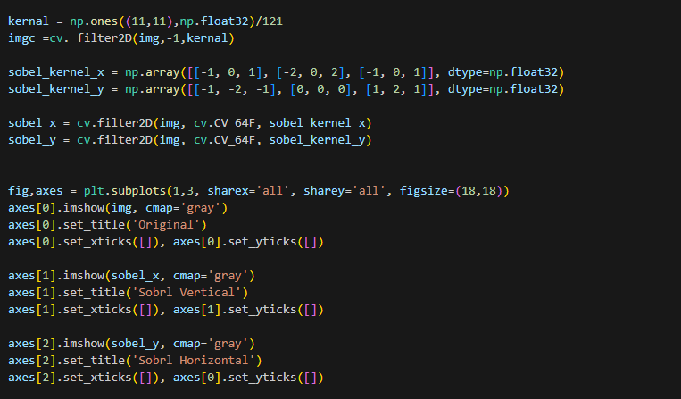

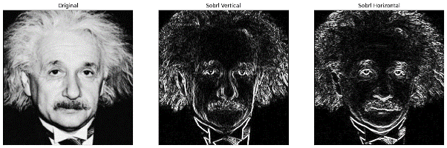b.

c.

Sobel filtering is a crucial technique in image processing that emphasizes intensity changes for edge detection. In the context of Figure 6, three approaches are employed. First, with the existing filter2D function, Sobel filtering may be completed efficiently and rapidly. Second, a custom Sobel filter implementation offers an interactive understanding of the underlying computations.

**Question 07**

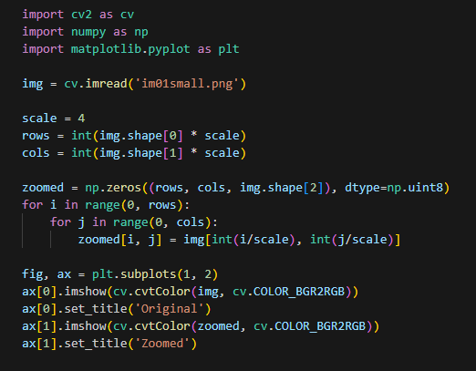

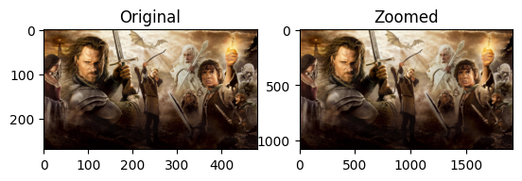

1. 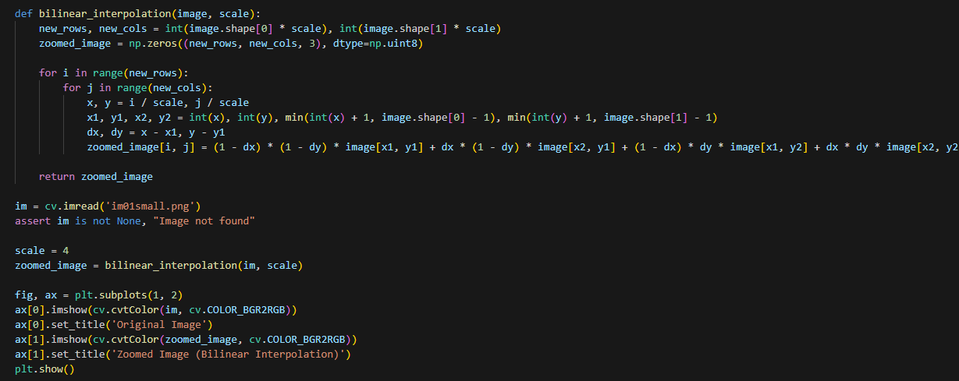

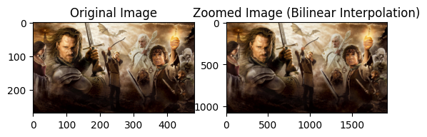

**Question 08**

1. A screen shot of a computer program

   Description automatically generated

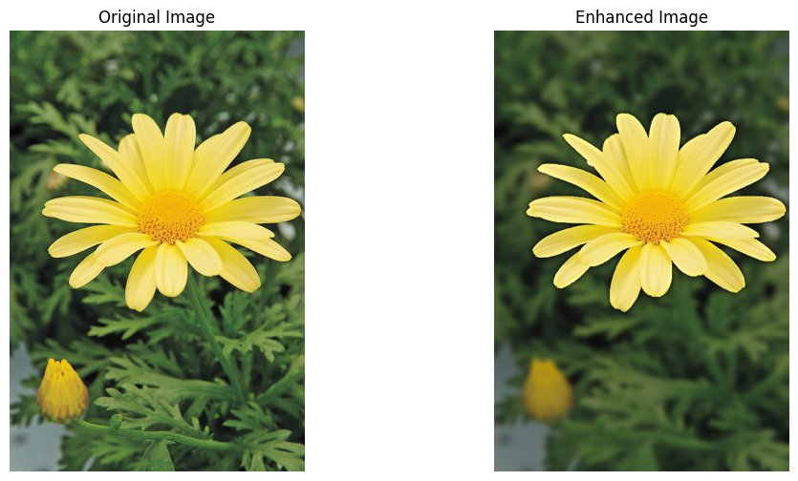

1. The improved image's darker backdrop, which extends over the margin of the flower, is mostly the outcome of a Gaussian blur applied to the background. The image is first divided into foreground (flower) and background using Grab Cut. The background is then smoothed using a Gaussian blur with a (15, 15) kernel. The backdrop appears darker because of this smoothing effect, which averages pixel values. The final improved image is produced by combining the sharp foreground with the blurred backdrop. The degree of blurring and the ensuing darkness in the backdrop can be altered by varying certain parameters, such as the kernel size.